P234

2．

#include <iostream>

using namespace std;

class student

{

public:

char name[2o];

unsigned int id;

double score;

void input(student&stu)

{

cout<<"name?";

cin>>stu.name;

cout<<"id?";

cin>>stu.id;

cout<<"score?";

cin>>stu.score;

}

void output(student&stu)

{

cout<<"name:"<<stu.name<<"\tid"<<stu.id<<"\tscore:"<<stu.score<<endl;

}

};

int main()

{

student s={"\0",0,0};

input(s);

output(s);

}

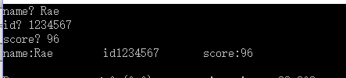

P242

1

#include <iostream>

using namespace std;

class Book

{

public:

char bookname[20] ;

double price, number;

int x;

void input(Book&bo)

{

cout<<"bookname? ";

cin>>bo.bookname;

cout<<"price? ";

cin>>bo.price;

cout<<"namber? ";

cin>>bo.number;

}

void display(Book&bo)

{

cout<<"bookname"<<"\t"<<bo.bookname<<"\t"<<"price"<<"\t"<<bo.price<<"\t"<<"namber"<<"\t"<<x<<endl;

}

int borrow(Book&bo)

{

x= bo.number-1;

return x;

}

int restore(Book&bo)

{

x=bo.number+1;

return x;

}

};

int main ()

{

Book one;

int a;

one.input(one);

cout<<"请选择 1-borrow , 2-restore"<<endl;

cin>>a;

if (a==1)

one.borrow(one);

else

one.restore(one);

cout<<"当前书本信息: ";

one.display(one);

}

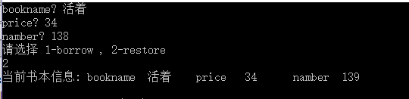

3

#include <iostream>

using namespace std;

class student

{

public:

double score[100],sum=0,ave;

static double count,total;

int i,j;

void soretotalcount()

{

cout<<"请输入人数: ";

cin>>student::count;

cout<<"请分别输入其分数: "<<endl;

for(i=0;i<count;i++)

{

cout<<"第"<<i+1<<"个 = "<<"\t";

cin>>score[i];

}

for(j=0;j<count;j++)

{

student::total=student::total+score[j];

}

}

void Sum()

{

cout<<"总分"<<student::total;

}

void average()

{

ave=student::total/count;

cout<<"平均数"<<ave;

}

};

double student::count=0;

double student::total=0;

int main()

{

student c;

c.soretotalcount();

cout<<endl;

c.Sum();

cout<<endl;

c.average();

}

